Hydrostatic Stability of Offshore Wind Turbines
Lakshmidhar Rao Brahma, LRB55
St. Catharine’s College, University of Cambridge
Overview
The aim of this project is to understand the stability of a vessel floating in water. Here, a simple system is considered, where the vessel is a solid, uniform prism of square cross-section that is infinitely long so that only two dimensions are considered. To understand the stability of the system, three different methods are considered: energy, GZ curves, and catastrophe theory. For all these methods, the decomposition shown below in Fig. 1 was performed to reduce the system into a superposition of the vessel and the displaced water individually, making the calculations simpler.
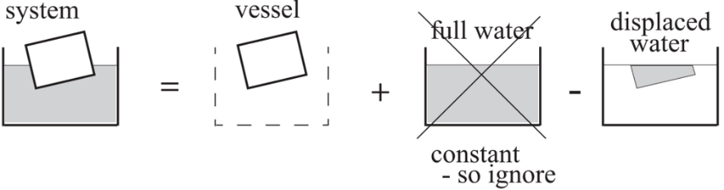
Figure 1: Equivalent decomposition of system
Method 1: Energy
The first method is to find and plot the potential energy of the system as function of heel angle for a given density. Both the stable and unstable equilibria can the be found from such a plot by the locations of minima and maxima such a plot. Python computation was used to create these plots, shown below in Fig. 2. Note that relative density, ρ, is the ratio of the vessel’s density to that of the fluid that suspends it (ρ = ρ_{v} / ρ_{f}). It has an upper limit of 1 as values greater than 1 would imply that the vessel sinks which is not relevant. Fig. 2(a) only features ρ up to 0.5 because a system with relative density, ρ, is mathematically identical to a system with relative density, 1-ρ (essentially swapping the air and the water).
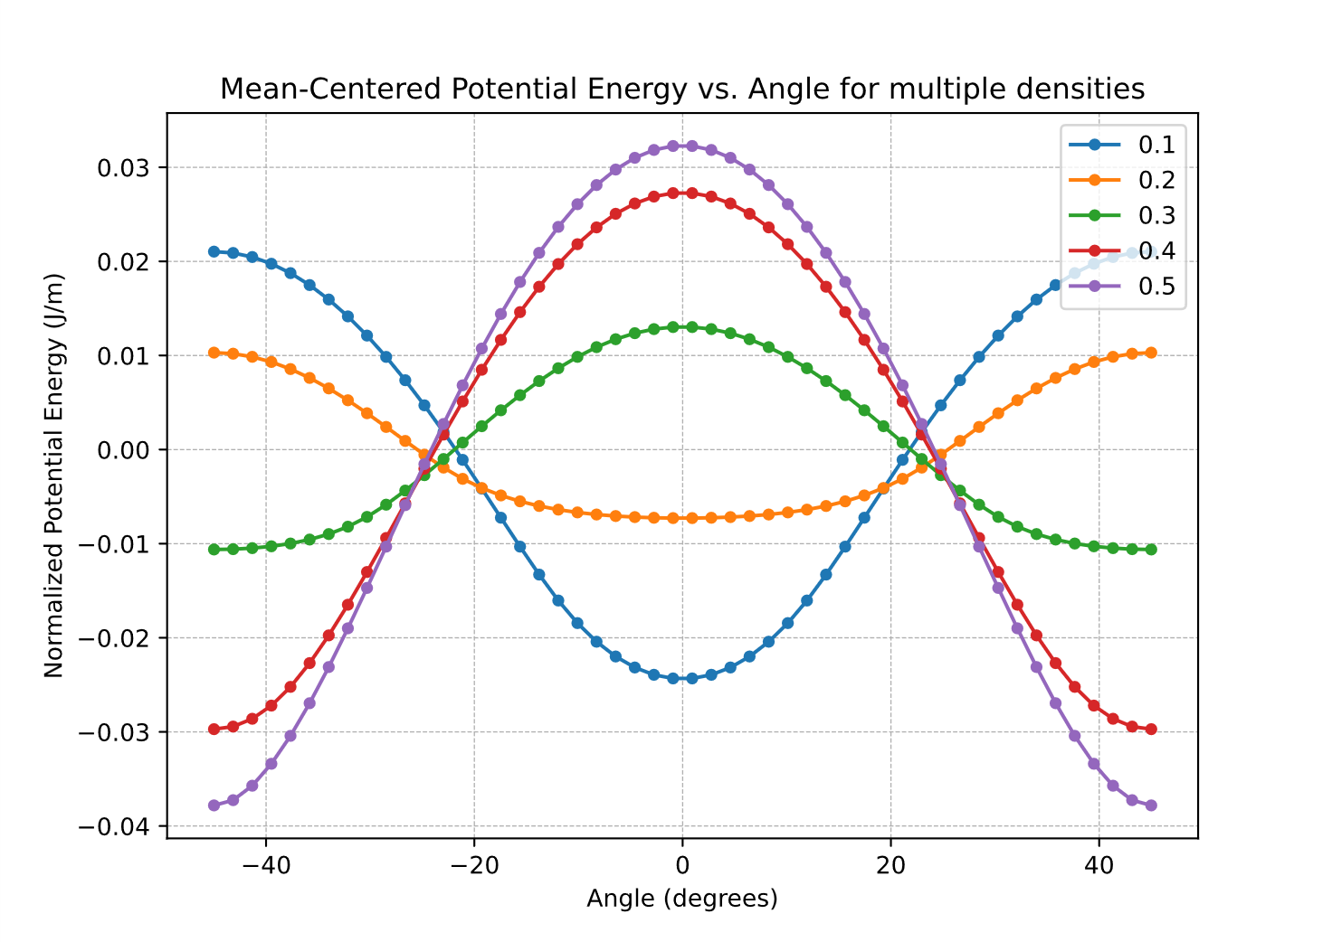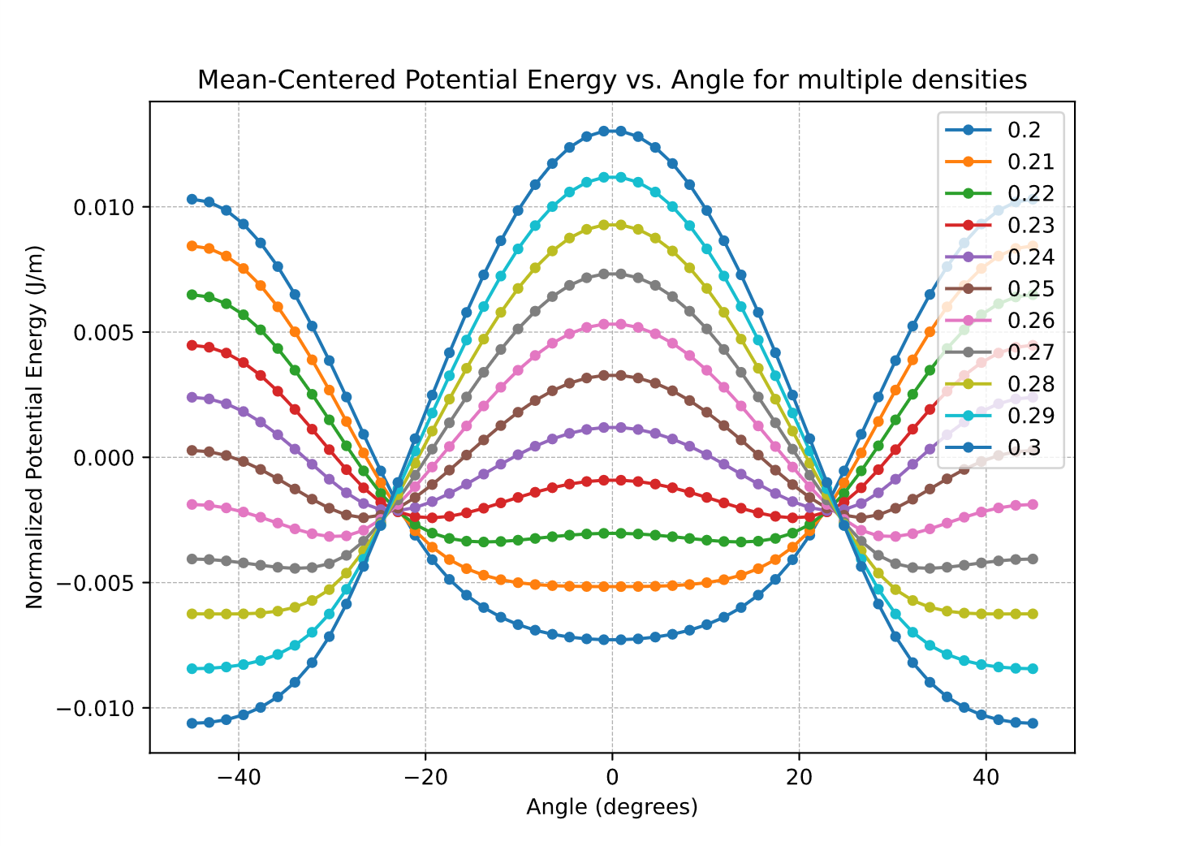
Fig. 2(a) Fig. 2(b)
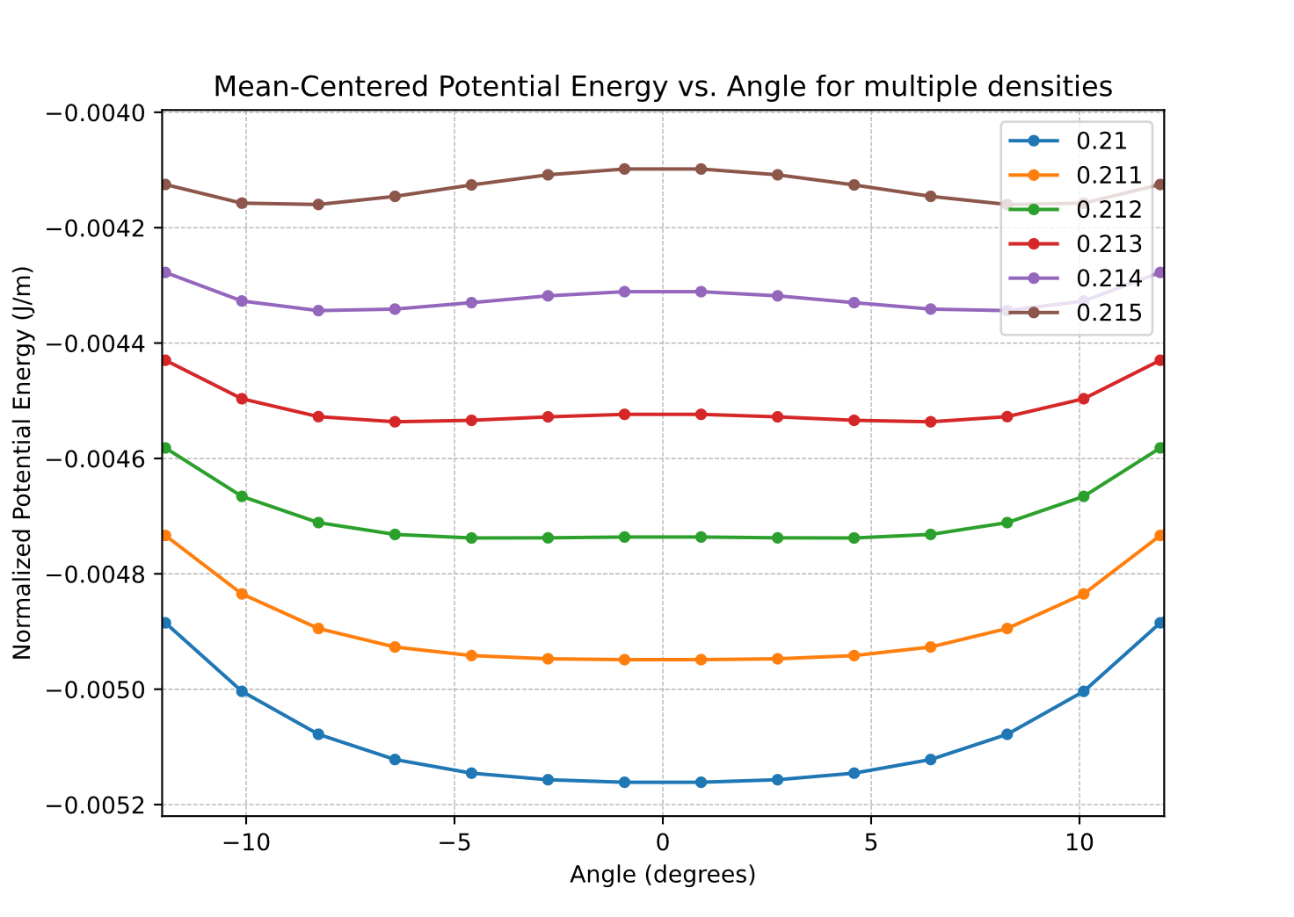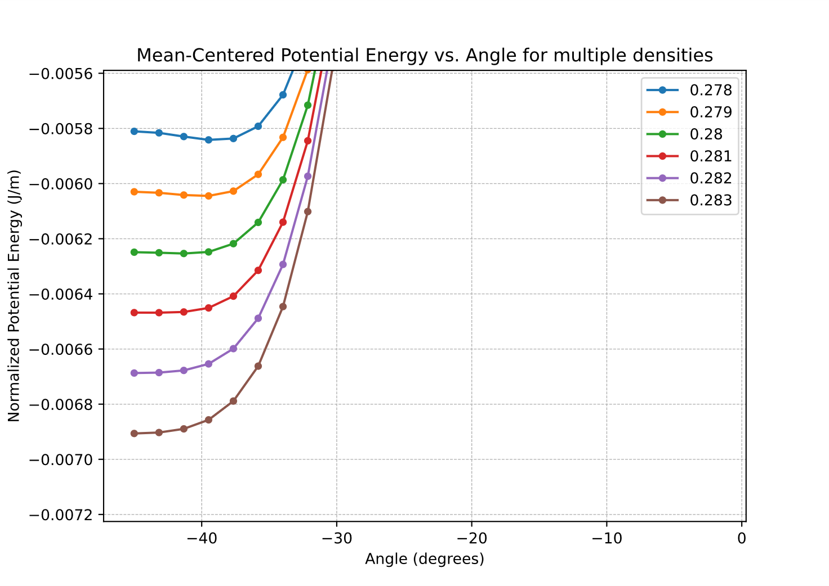
Fig. 2(a) Fig. 2(b)
Figure 2: Plots of mean-centred potential energy against heel angle for varying relative densities (see legends)
Fig. 2(a) shows that for all values of ρ, there are three equilibrium angles: 0º and +-45º. The system seems to be stable at 0º and unstable at +-45º for ρ close to 0 (and close to 1 due to the symmetry around ρ=0.5). The stability of these equilibria then ‘flip’ when ρ is near 0.5.
To further investigate this switch, plots with smaller ρ increments between 0.2 and 0.3 were graphed in Fig. 2(b). These curves reveal that during the switch, all three points become unstable equilibria, and that there are in fact two new stable equilibria known as the angle of loll, +-thetaL, that gradually shifts from 0º to +-45º as ρ changes.
Even smaller increments of ρ were plotted in Figs. 2(c) and 2(d) to determine the critical values of ρ for which these angles of loll exist. To one decimal place, this region appears to be 0.21<ρ<0.28 and, using symmetry about ρ=0.5 again, 0.72<ρ<0.79.
In order to gain a visual understanding of these changes, the bifurcation diagram in Fig. 3 was plotted which show the traces of equilibrium paths. This was done for the stable equilibria by python computation of the minima locations for a hundred of the energy functions such as in Fig. 2. The unstable paths were sketched manually since they are trivially found by inspection.
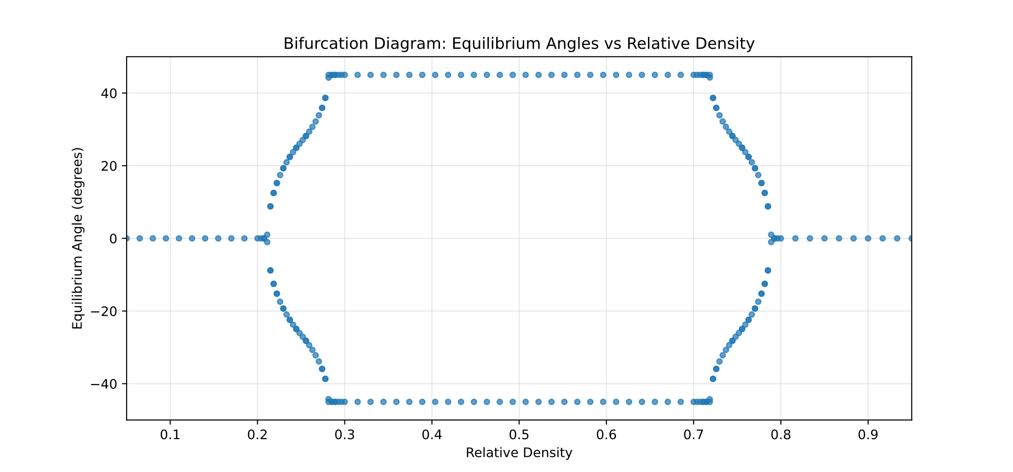
Figure 3: Bifurcation diagram showing equilibrium paths; stable paths (blue) were plotted using python code but unstable paths (red) were sketched on manually
Method 2: GZ Curves

Method 3: Catastrophe Theory

Environmental Impact

Conclusions

